**Contacts App Project Overview - contactsappweb**

**CRUD RESTful web service using AngularJS.**

**NB: This illustrate the power of SPA through AngularJS.**

**This app will allow a user to:**

**--  View a list of contacts and perform search**

**--  Add a contact**

Id – system generated – auto increment

Name – user selected name i.e. Will Smith

Phone – 11 characters NB. SA phone code is +27

Address – user selected address i.e. 1446 Lynwood Road Drive.

All fields are required.

**--  Edit a contact**

**--  Delete a contact**

**List of contacts.**

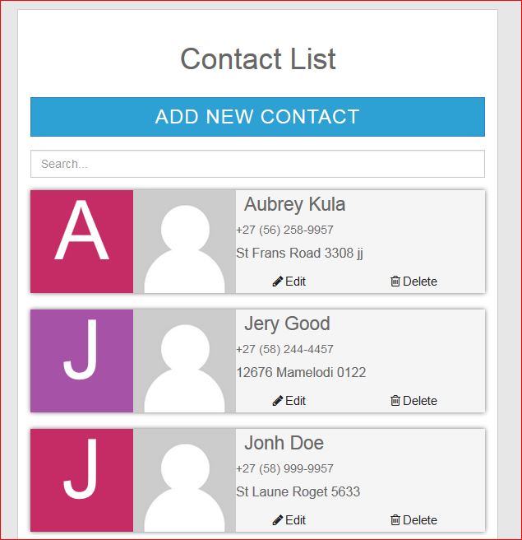

**Perform the contacts search.**

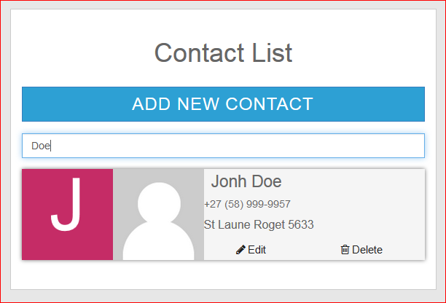

**Add new contact.**

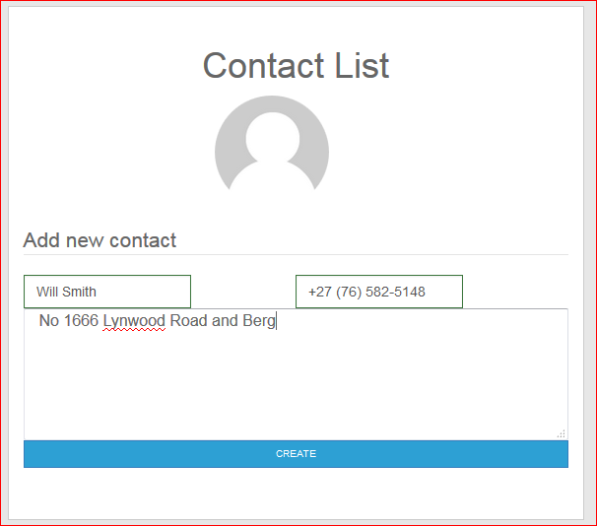

**Contacts is created successfully.**

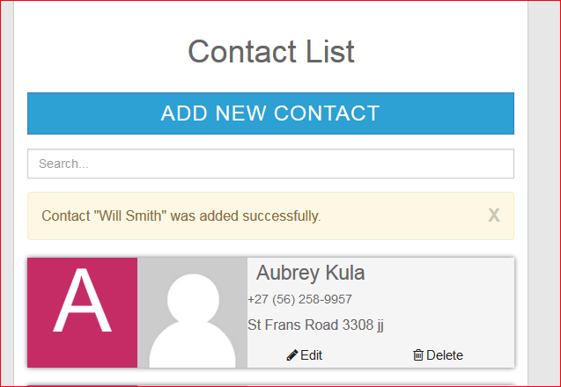

**Edit the contact.**

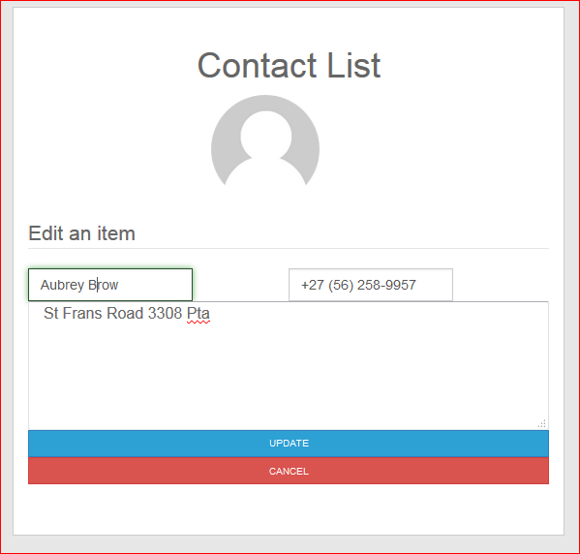

**Contacts updated successfully.**

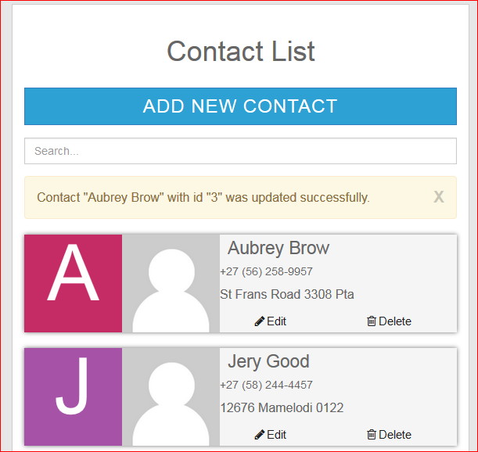

**Delete the contact.**

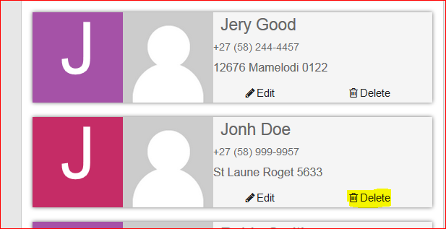

**Confirm delete.**

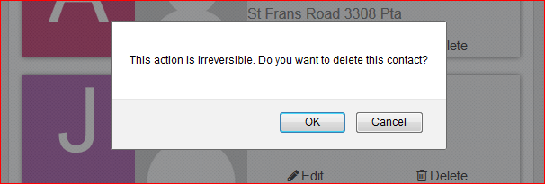

**Contact deleted.**

